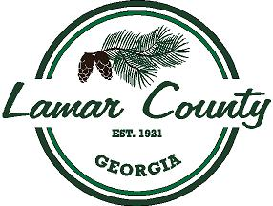
LAMAR COUNTY BOARD OF COMMISSIONERS
Workshop Meeting
Administration Building
May 15, 2025, 12:30 PM
Agenda
1. Call to Order
2. Workshop Meeting Items for Discussion
i. Enterprise Fleet Management
ii. Haunted House-Old Jail Museum
3. Regular Meeting Discussion
4. Administrator's Report
5. Public Comment
6. Round Table
7. Executive Session
i. Real Estate
ii. Litigation
iii. Personnel
8. Executive Session

